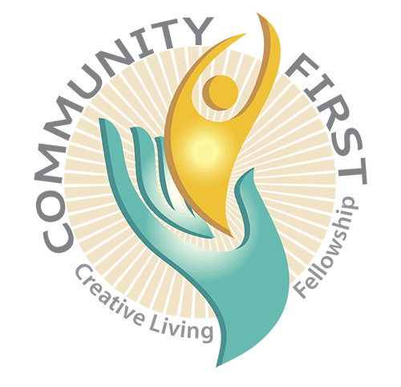
APPLICATION FOR CLF CIRCLE MEMBERSHIP

Congratulations! We honor and applaud you for taking this important step in the direction of greater intimacy, spiritual growth, care and connection by applying to become a member of a CLF (CareLoveFriendship) Circle. Our Circles are the place where community happens and where you can experience feeling loved and appreciated like never before!

A FEW THINGS TO KNOW ABOUT CLF CIRCLES

Here’s some important information to help you decide if joining a CLF Circle is right for you. Please prayerfully consider the following before submitting the attached Application.

- TIME COMMITMENT - CLF Circles meet once a month typically on the same day of the month (example – every third Wednesday). Circles typically meet 10-11 times a year. Because of the intimacy that happens in Circles, we ask you to check your schedule to confirm you can commit to attending most, and ideally all, of the gatherings. Of course, we understand that conflicts may come up occasionally (e.g., vacations, work commitments, health issues, etc.), but we ask that you commit to keeping your Circle Leader informed if you will miss a meeting in these the cases. Barring that, are you willing to make Circle attendance a priority in your life and in your schedule?

- WHERE GROUPS MEET - Groups typically meet in one of the Co-Leader’s homes for care, connection, spiritual practice, love and laughter. Some Circles, meet in a Circle member’s home. You are not required to host a Circle gathering. This is optional and only for those Circle members who want to host and have a home that is conducive for a Circle.

- ONLY KINDNESS - Because CLF Circles are committed to creating a safe place for sharing, each member is asked to respect some very important agreements such as confidentiality, non-judgment, no advice giving and no gossip. We practice speaking kindly, being patient, praying for each other and allowing each member of the Circle to mature along their spiritual path at their perfect pace.

- LOVING COMMUNICATION – Part of our Circles’ focus is to grow together in how we communicate, thus co-creating a more loving world. This change begins with us – right in our CLF Circles. Sometimes a person will trigger you and you will feel angry, afraid, sad, etc. We welcome and honor all our feelings and at the same time, we practice sharing them in ways that increase connection and decrease defensiveness.

- WILLING TO BE SUPPORTED – Every CLF Circle has Co-Leaders who dedicate their time to making sure you are loved, appreciated and prayed for. We ask all Circle members to lean into their Co-Leaders for prayer and care in personal, professional and all ways.

[Please keep this sheet for yourself and submit the attached Application.]
CLF CIRCLE APPLICATION
(Please turn this portion of the Application into the Creative Living Fellowship office
or email it to: admin@creativelivingfellowship.com. Retain the first page for your reference.)

Date: __________________________________

Full Name: ____________________________________________________________________________________________

Address: ____________________________________________________________________________________________

Best Phone: ____________________________________________________________________________________________

Email: ____________________________________________________________________________________________

How long have you been coming to CLF? ___________ years __________ months

Are you a member? Yes No

Are you willing and able to make your CLF Circle a high priority in your life, and therefore your calendar? Yes No

What do you hope or imagine you could gain from being in a CLF Circle?
________________________________________________________________________________________________________

_________________________________________________________________________________________________________

What gifts and blessings might you bring to the CLF Circle? (e.g., good listener, compassionate, commitment, timeliness, desire to grow spiritually, supportive, etc.)
_________________________________________________________________________________________________________

_________________________________________________________________________________________________________

What reservations, if any, do you have around joining a CLF Circle?
_________________________________________________________________________________________________________

_________________________________________________________________________________________________________

Are you interested in learning about Circle Co-Leader training (prerequisites: successfully completed the Foundations class and a member of CLF)? Yes No

Are you willing to go direct and have adult conversations with your Circle Leaders should any issue arise within your Circle with which you are uncomfortable or upset? Yes No

CLF Circle location preference (major cross streets and city, please):

_________________________________________________________________________________________________________

Are you willing to travel outside your preference area to a Circle meeting? Yes No
If so, how far one way? _____ 5 miles _____ 10 miles _____15 miles _____ 15+ miles

I’m allergic to: _____ Cats _____ Dogs _____ Smoke _____ Other: ___________________________

I have children and would like to be in a group that includes child care. Yes No
If yes, I am willing/able to help pay for the care. Yes No

